In-Depth Research Report:- Host Header Injection and Password Reset Poisoning

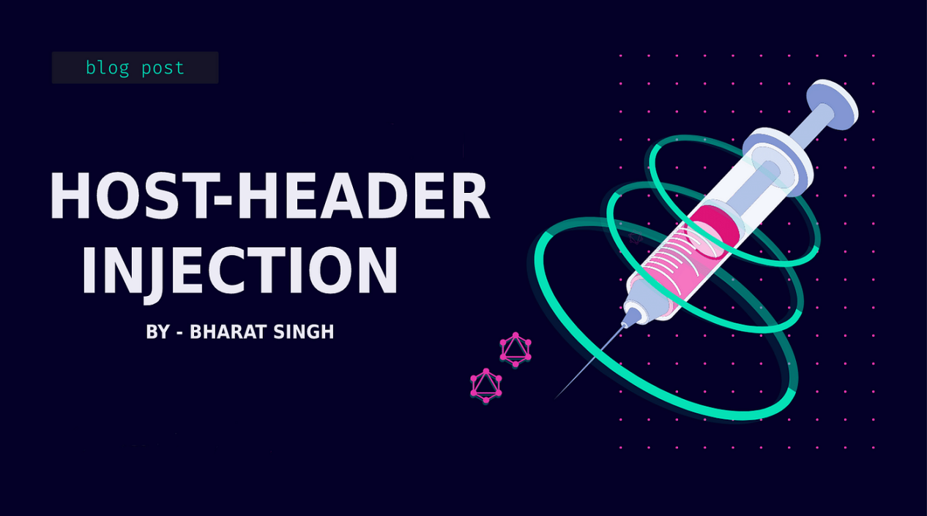

1. Introduction
Web applications frequently utilize HTTP headers, particularly the Host header, to manage requests and responses. This report delves deeply into Host Header Injection and Password Reset Poisoning, detailing their definitions, mechanics, impacts, and effective mitigation strategies.

2. What is a Host Header?
The Host header is an essential component of the HTTP/1.1 protocol, introduced to facilitate virtual hosting, where multiple domain names can point to a single IP address. It specifies the domain name of the server handling the request, allowing the web server to determine the correct resource to serve.

Example of a Host Header:
http
Copy code
GET / HTTP/1.1
Host: www.example.com
In this example, the Host header indicates that the request is for the resource located at www.example.com.

3. What is Host Header Injection?
Host Header Injection occurs when an attacker manipulates the Host header in an HTTP request to exploit vulnerabilities in a web application. This can lead to unauthorized actions or facilitate other attacks.

Mechanism of Host Header Injection:
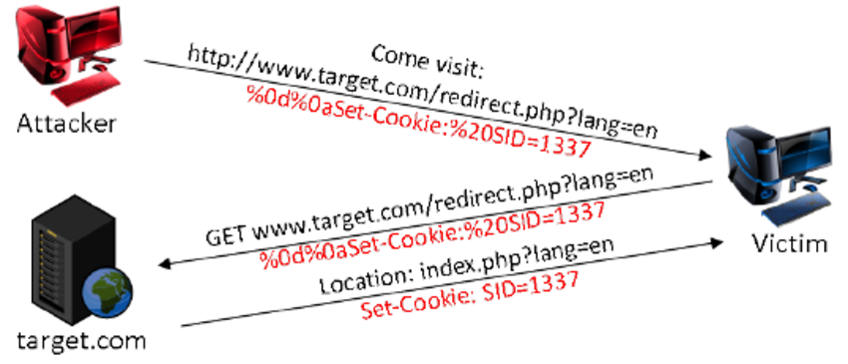
- Crafting a Malicious Request: The attacker alters the Host header in an HTTP request.
- Server Interpretation: If the server relies on the Host header for routing, generating URLs, or security measures, it may behave unexpectedly.
- Exploitation: The attacker may redirect users, poison caches, or bypass security mechanisms.

Common Attack Vectors:
- Redirecting Users: By altering the Host header, attackers can redirect legitimate traffic to malicious sites, potentially capturing sensitive data.
- Cache Poisoning: A manipulated response can be cached by intermediate proxies, affecting all users accessing the cached data.
- Bypassing Security Controls: If an application uses the Host header for access control, a malicious header can allow unauthorized access.

Example Scenario:
An attacker sends a request with the following Host header:
http
Copy code
Host: malicious.com
If the server uses this header to generate links or redirects, users may unknowingly visit a phishing site.

Impact of Host Header Injection
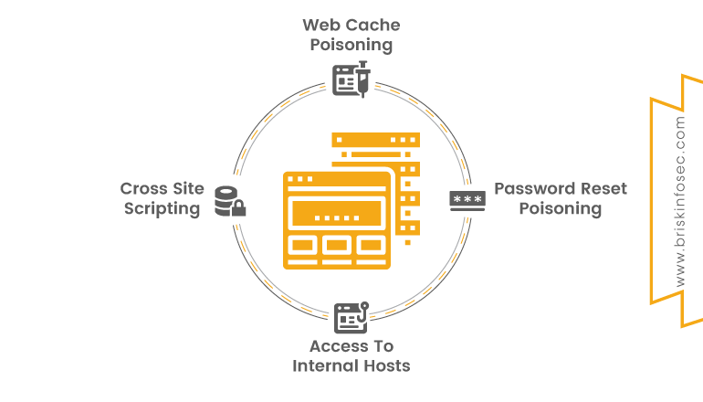
The ramifications of Host Header Injection can be severe:
- Security Bypass: Attackers can exploit the application’s trust in the Host header to gain unauthorized access or data.
- Phishing: Redirecting users to malicious sites can lead to credential theft and further compromises.
- Cache Poisoning: A successful cache poisoning attack can spread malicious content across a wide range of users, leading to widespread issues.
- Reputation Damage: If users are affected by phishing or malware, it can severely damage an organization’s reputation and trustworthiness.

Real-World Examples:
- GitHub Incident (2016): Attackers exploited host header injection to redirect users to a malicious site.
- Various E-commerce Sites: Instances of redirecting customers to phishing sites by manipulating host headers.

What is Password Reset Poisoning?
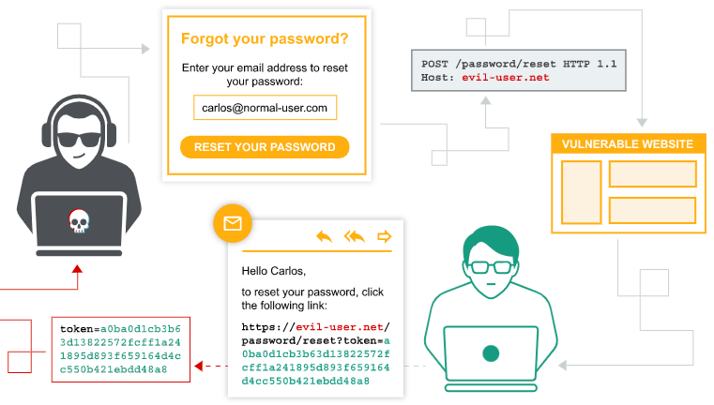
Password Reset Poisoning is an attack that exploits weaknesses in the password reset process to gain unauthorized access to user accounts.

Mechanism of Password Reset Poisoning:
- Manipulating User Input: Attackers send requests that manipulate the password reset process, often changing email addresses or tokens.
- Receiving Reset Tokens: If the application does not properly validate or authenticate requests, attackers may receive reset tokens or links meant for other users.
- Unauthorized Access: By obtaining these tokens, attackers can reset passwords and gain control over accounts.

Common Attack Vectors:
- Email Change Exploitation: An attacker might change the email address associated with an account to redirect reset emails.
- Token Guessing or Brute Force: If tokens are predictable, attackers may guess or brute-force their way into accounts.

Example Scenario:
An attacker sends a request to change the password for an account, modifying the email address to one they control. They then receive the reset link, allowing them to change the password and lock the legitimate user out.

6. Impact of Password Reset Poisoning
The impacts of Password Reset Poisoning can be equally damaging:
- Account Takeover: Attackers can gain complete control over user accounts, accessing sensitive information or making unauthorized transactions.
- Data Breach: Compromised accounts can lead to data breaches, exposing personal and financial information.
- Loss of User Trust: If users feel their accounts are not secure, they may abandon the service, leading to a loss of business and reputation.
- Financial Loss: Organizations may face legal repercussions and financial penalties due to compromised accounts.

Real-World Examples:
- Twitter Incident (2020): High-profile accounts were compromised through social engineering techniques, including password reset attacks.
- Various SaaS Applications: Reports of users losing access to accounts due to poorly implemented password reset processes.

7. Mitigation Measures

For Host Header Injection:
Input Validation: Ensure that the Host header is validated against a whitelist of expected values. Reject any request with an unexpected Host header.
Default Host Configuration: Configure web servers to return a default response if the Host header is missing or invalid.
Use of Absolute URLs: Generate URLs using server-side configurations rather than relying solely on the Host header. This can prevent redirection based on manipulated headers.
Web Application Firewall (WAF): Implement a WAF to detect and block malicious requests based on patterns associated with host header attacks.
Logging and Monitoring: Maintain logs of incoming requests and monitor for unusual patterns that may indicate an ongoing attack.

For Password Reset Poisoning:
Email Verification: Require email verification prior to processing password reset requests. This adds an extra layer of security.
Token Validation: Ensure that password reset tokens are short-lived and unique for each request. Use cryptographic methods to generate tokens.
Rate Limiting: Implement rate limiting on password reset requests to reduce the risk of brute-force attempts.
Multi-Factor Authentication (MFA): Encourage users to enable MFA for added security during password resets.
User Education: Inform users about phishing tactics and how to identify secure links to protect their accounts.

8. Conclusion
Host Header Injection and Password Reset Poisoning represent significant threats to web applications, capable of compromising user data and damaging reputations. By understanding these vulnerabilities and implementing robust security measures, organizations can better protect their applications and users from potential attacks.

9. References
- OWASP. (n.d.). Host Header Injection.
- OWASP. (n.d.). Password Reset Cheat Sheet.
- Security Research Labs. (2020). How Host Header Attacks Work.
- Acunetix. (2021). Host Header Attacks.
- Veracode. (2020). The Dangers of Password Reset Functionality.
- SANS Institute. (2019). Mitigating Host Header Attacks.

